시퀀스 다이어그램 예제

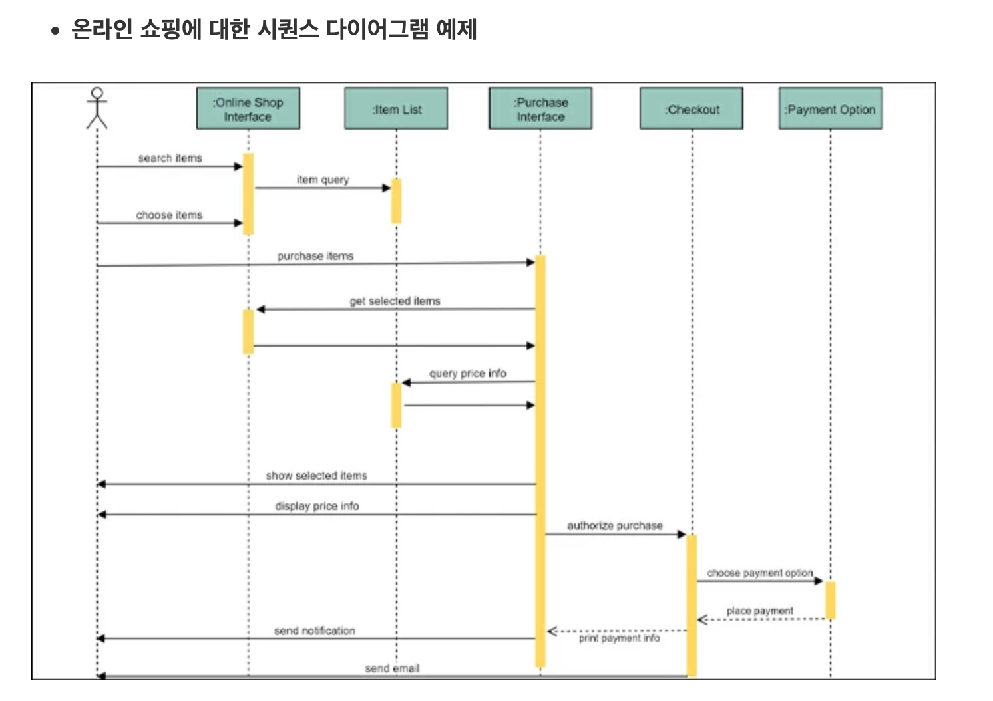

* URL: <https://gitmind.com/kr/sequence-diagram-example.html>

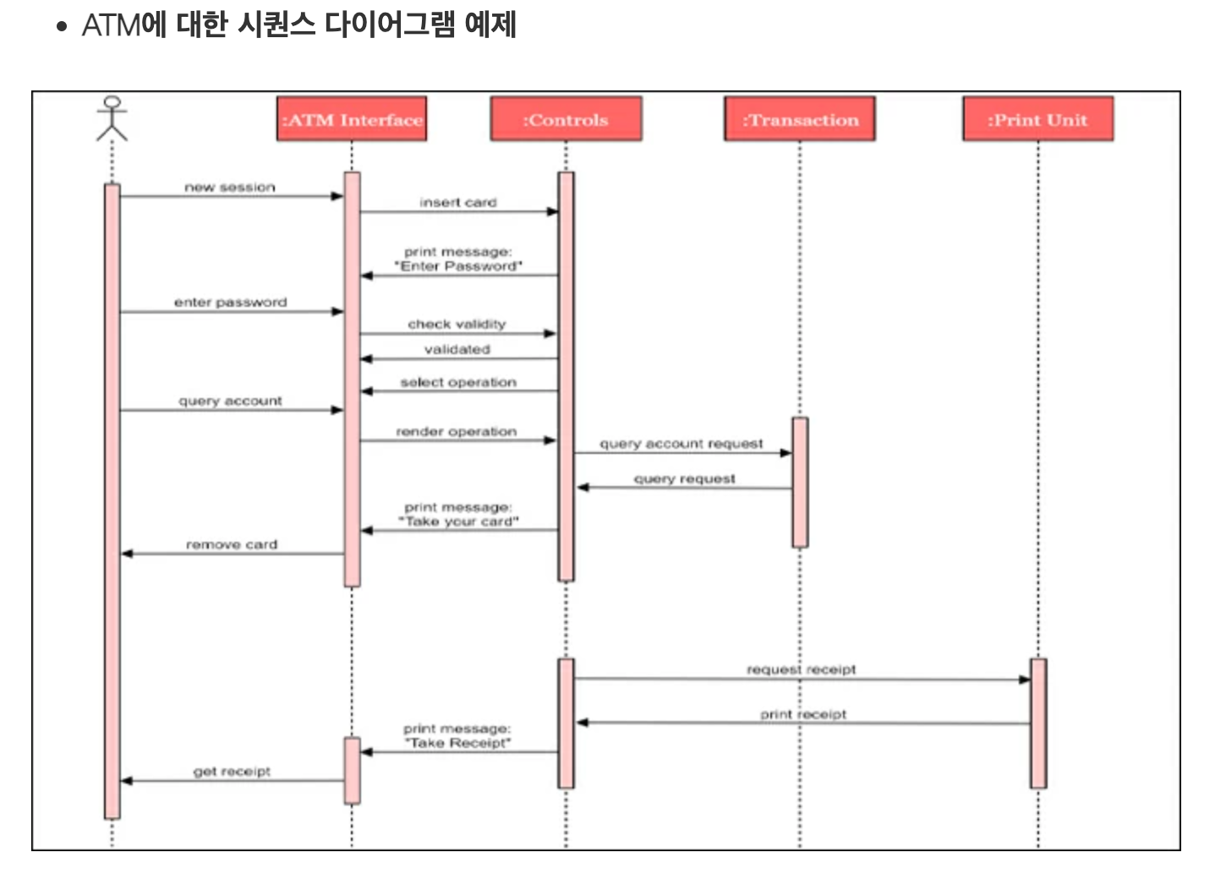

* URL: <https://gitmind.com/kr/sequence-diagram-example.html>

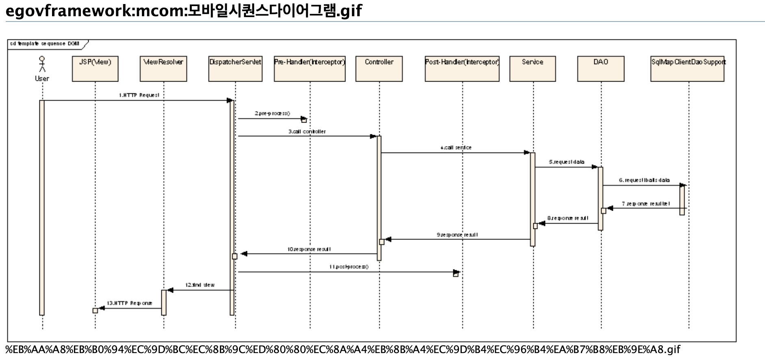

* 주소: <https://www.egovframe.go.kr/wiki/lib/exe/detail.php?id=egovframework%3Amobile_common_component_system&media=egovframework:mcom:%EB%AA%A8%EB%B0%94%EC%9D%BC%EC%8B%9C%ED%80%80%EC%8A%A4%EB%8B%A4%EC%9D%B4%EC%96%B4%EA%B7%B8%EB%9E%A8.gif>